Nicholas Skinner

CS321

Fall 2019

Homework 1

1. **For the DFA M below, give its formal definition as a quintuple. Verbally describe the language, L(M), accepted by M.**
   1. M1 = (Q, Σ, δ, q0, F)
      1. Q = {q0, q1, q2, q3}
      2. Σ = {0,1}
      3. δ =

|  |  |  |
| --- | --- | --- |
| δ | 0 | 1 |
| q0 | q1 | q3 |
| q1 | q1 | q2 |
| q2 | q2 | q2 |
| q3 | q1 | q3 |

* + 1. Q0 = {q0}
    2. F = {q1, q3}
  1. **Verbal description:** It does not accept lambda, and all instances of a 1 must occur before a 0, if a 1 occurs after a 0, the result will be rejected

1. **For each of the following languages over the alphabet = {a, b}, give a DFA that recognizes the language.**
   1. **L1 = { λ, b, ab}**
      1. M1 = (Q, Σ, δ, q0, F)
      2. Q = {q0, q1, q2, q3}
      3. Σ = {λ, a, b}
      4. δ=

|  |  |  |
| --- | --- | --- |
| δ | a | b |
| q0 | q2 | q1 |
| q1 | q3 | q3 |
| q2 | q3 | q1 |
| q3 | q3 | q3 |

* + 1. Q0 = {q0}
    2. F = {q1}
    3. Diagram: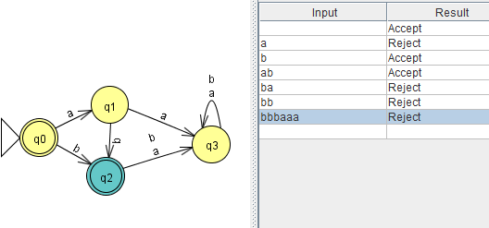
  1. **L2 = { w * | w begins with an “a” and ends with a “b” } .** 
     1. M1 = (Q, Σ, δ, q0, F)
     2. Q ={q0,q1,q2,q3}
     3. Σ = {a,b}
     4. δ=

|  |  |  |
| --- | --- | --- |
| δ | a | b |
| q0 | q1 | q3 |
| q1 | q1 | q2 |
| q2 | q1 | q2 |
| q3 | q3 | q3 |

* + 1. Q0 = {q0}
    2. F = {q2}
    3. diagram: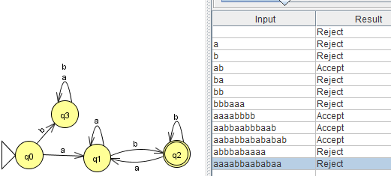
  1. **For any string w * , let na(w) denote the number of a’s in w. For example na(abbbba) = 2. Define the language L3 = { w * | na(w) mod 3 = 1}.**
     1. M1 = (Q, Σ, δ, q0, F)
     2. Q = {q0, q1, q2}
     3. Σ = {a,b}
     4. δ=

|  |  |  |
| --- | --- | --- |
| δ | a | b |
| q0 | q1 | q0 |
| q1 | q2 | q1 |
| q2 | q0 | q2 |

* + 1. Q0 = {q0}
    2. F = {q1}
    3. Diagram: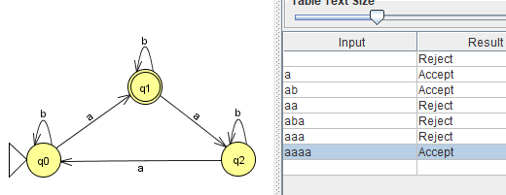
  1. **L4 = !𝐿3 where L3 is the language in part c)**
     1. M1 = (Q, Σ, δ, q0, F)
     2. Q ={q0,q1,q2}
     3. Σ = {a,b}
     4. δ=

|  |  |  |
| --- | --- | --- |
| δ | a | b |
| q0 | q1 | q0 |
| q1 | q2 | q1 |
| q2 | q0 | q2 |

* + 1. Q0 = {q0}
    2. F ={q0, q2}
    3. Diagram: 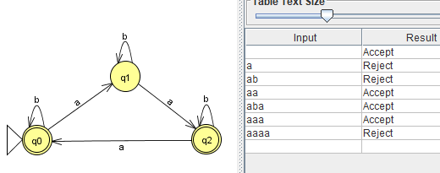

1. **Let L = {w {0, 1}* such that w is a binary representation of an odd integer}. Show that L is a regular language.**
   1. M1 = (Q, Σ, δ, q0, F)
   2. Q = {q0, q1}
   3. Σ = {0,1}
   4. δ=

|  |  |  |
| --- | --- | --- |
| δ | 0 | 1 |
| q0 | q0 | q1 |
| q1 | q0 | q1 |

* 1. Q0 = {q0}
  2. F = {q1}

Diagram:

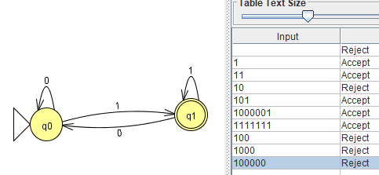

1. **2 parts:**
   1. **Find an nfa with three states that accepts the language L = {an : n ≥ 1 } { b^m a^k : m ≥ 0, k ≥ 0 }**

**NFA:**

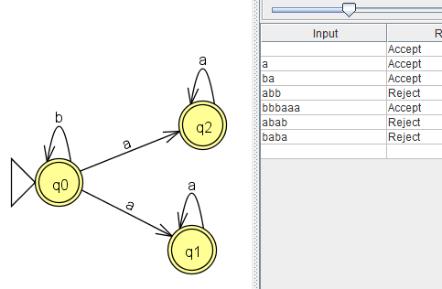

* 1. **b) Do you think that the language in part (a) can be accepted by an nfa with fewer than three states?**

I believe the following is able to represent the language from part A in an equivalent manner, it restricts it such that if the letter B occurs, the letter A can only come after a B, and not before it.it will also accept everything from the a^n >1 portion of the language.

The initial state can be a final state, as our second part of the unioned language accepts no a or b input, so lambda is acceptable.

